**Return a list of results**

**Set up a Dataverse Account table**

The Account table is a [standard table](https://learn.microsoft.com/en-us/power-apps/maker/data-platform/types-of-entities) that's included automatically in Power Platform environments. However, it doesn't come with account data. Before your agent can search for accounts, you'll need to populate the Account table.

If you already have an Account table with data, skip this step and move on to [Create a topic](https://learn.microsoft.com/en-us/microsoft-copilot-studio/advanced-flow-list-of-results#create-a-topic). However, you'll need to use different search terms when you test your agent in later steps.

1. Go to the [Power Apps portal](https://make.powerapps.com/).
2. In the side pane, under **Dataverse**, select **Tables**.
3. Select the **Account** table, and then on the table properties page, select **Edit**.
4. Add the following rows to the table:

Expand table

| **Address 1: City** | **Account Name** | **Account Number** |
| --- | --- | --- |
| Seattle | Contoso Inc | AC0125 |
| San Francisco | Contoso Residences | AC0255 |
| Olympia | Contoso Meal Delivery | AC0035 |

**Create a topic**

1. Go to the [Topics](https://learn.microsoft.com/en-us/microsoft-copilot-studio/authoring-create-edit-topics) page for your agent.
2. Create a topic called **Account Search**.
3. Add the following trigger phrases:
   * I'm looking for a customer
   * I'm looking for an account
   * search account
   * search customer
4. Add a **Message** node and enter the message **Sounds like you're looking for an account. I can look that up for you.**.
5. Add a **Question** node and enter the message **What's the name of the customer you're looking for?**.
6. For **Identify**, select **Organization**.

**User's entire response** will also work. However, selecting the **Organization** entity takes advantage of the agent's language understanding capabilities to extract the organization name from the response.

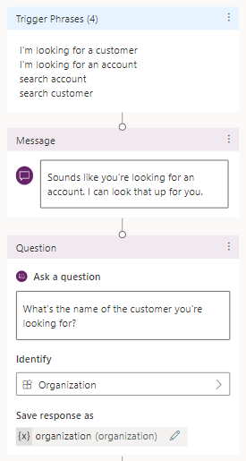

1. For **Save response as**, rename the variable to **organization**.

**Create a flow**

1. On the authoring canvas, select **Add node** (**+**). Select **Call an action**, and then select **Create a flow**.
2. In the Power Automate portal, name the flow **Search Account**.
3. Add a **Text** input named **Organization**.

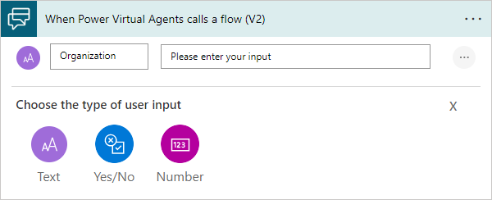

1. Select **Insert a new step** (**+**) and select **Add an action**.
2. Select the **Microsoft Dataverse** connector, and then select the **Search rows** action.

This action uses fuzzy matching to find relevant accounts in your [Dataverse Account table](https://learn.microsoft.com/en-us/power-apps/maker/data-platform/entity-overview).

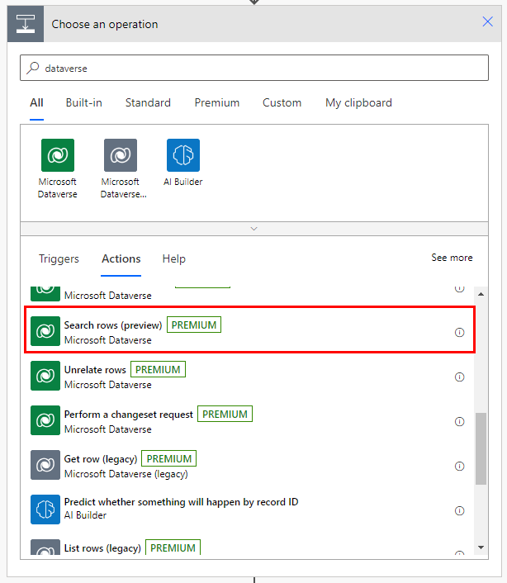

1. For **Search term**, select the **Organization** variable.
2. Select **Show advanced options** and set the following items as given:
   * **Table filter Item**: account
   * **Sort by Item - 1**: @search.score desc
   * **Sort by Item - 2**: name asc

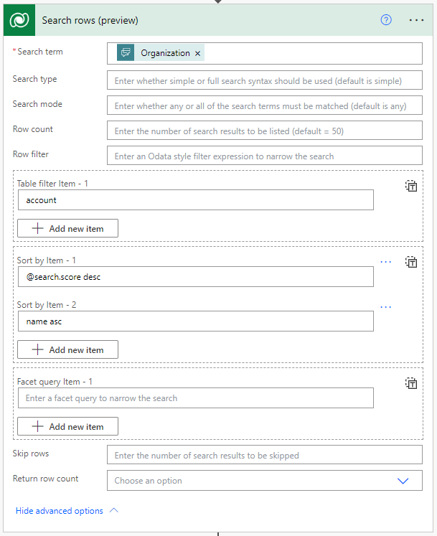

**Format results**

The **Search rows** action returns the **List of rows** variable, which contains JSON data. Before you can use the data, you'll need to analyze it with the **Parse JSON** action.

1. Select **Insert a new step** (**+**) and select **Add an action**.
2. Select the **Data Operation** connector, and then select the **Parse JSON** action.
3. In the **Content** box, under **Search rows**, select the **List of rows** variable.
4. Copy the following JSON schema and paste it in the **Schema** box:

JSONCopy

{

"type": "array",

"items": {

"type": "object",

"properties": {

"@@search.score": {

"type": "number"

},

"name": {

"type": "string"

},

"address1_city": {

"type": "string"

},

"accountnumber": {

"type": "string"

}

},

"required": [

"name"

]

}

}

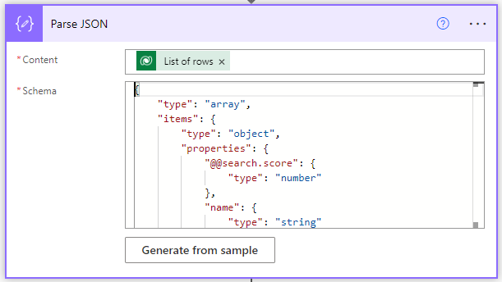

1. Select **Insert a new step** (**+**) and select **Add an action**. Select the **Variable** connector, and then select the **Initialize Variable** action.
2. For **Name**, enter **ListOfAccounts**. For **Type**, select **String**.

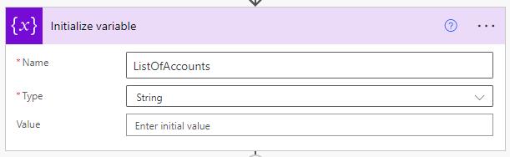

1. Select **Insert a new step** (**+**) and select **Add an action**. Select the **Control** connector, and then select the **Apply to each** action.
2. Select the **Select an output from previous steps** box to open the **Dynamic content** menu. Search for **body**, and then under **Parse JSON**, select the **Body** variable.
3. Select **Insert a new step** (**+**) and select **Add an action**. Select the **Variable** connector, and then select the **Append to string variable** action.
4. For **Name**, select **ListOfAccounts**. Copy the following text and paste it in the **Value** box:

PowerApps FormulaCopy

- @{items('Apply_to_each')['accountnumber']}: @{items('Apply_to_each')['name']} - @{items('Apply_to_each')['address1_city']}

1. Add a line break after the snippet to make each result appear on its own line.

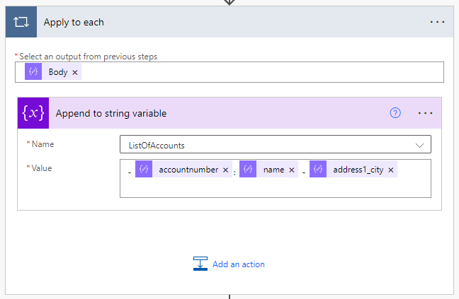

1. In the **Return value(s) to Microsoft Copilot Studio** action, add a **Text** output. For **Name**, enter **FoundAccounts**. For **Value**, select **ListOfAccounts**.

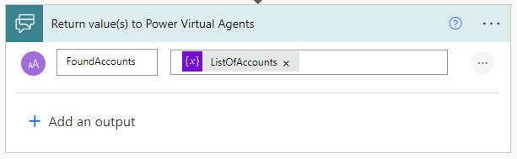

1. Select **Save**.

**Call the flow from Microsoft Copilot Studio**

1. On the Microsoft Copilot Studio authoring canvas, select **Add node** (**+**), and then select **Call an action**.
2. Select the flow you created earlier, **Search Account**.
3. For **Organization gets value from**, select the **organization** variable.
4. Add a **Message** node and enter the message **Okay, this is what I found.**
5. Add a second **Message** node. Select **Insert variable**, and then select **FoundAccounts**.

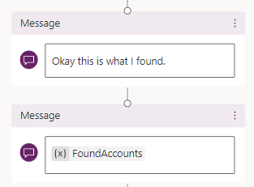

1. Select **Save**.
2. Test your agent in the **Test agent** pane.

